

PHYSICAL EDUCATION
PHYSICAL EDUCATION

FIRST YEAR

year 2024/2025.

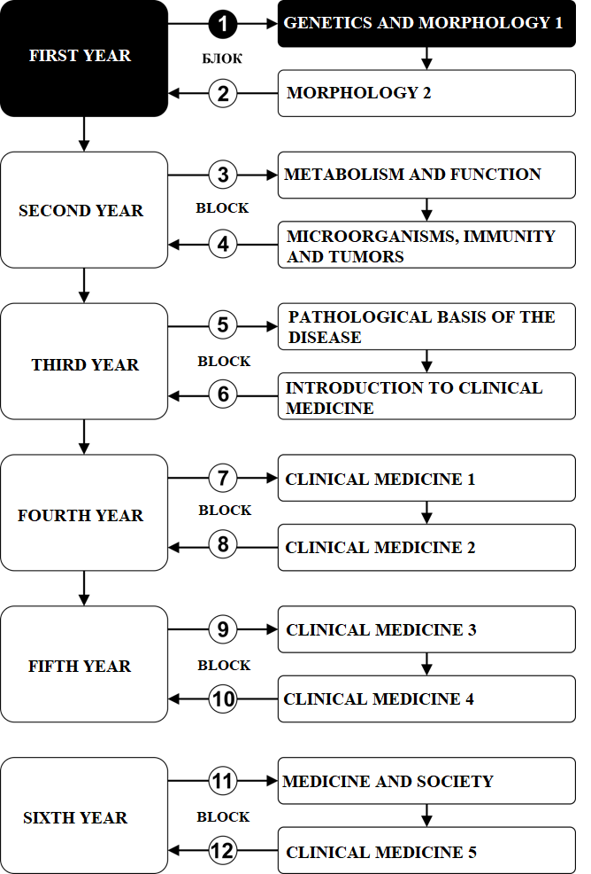

Subject:

PHYSICAL EDUCATION

The course is evaluated with 3 ECTS. There are 4 active classes per week (1 class of theory and 2 classes of work in a small group).

PROFESSORS AND ASSOCIATES:

РБ | Name and surname | Email | Title
1. | Emilija Stojanović | stojanovic.emilija@yahoo.com | Assistant professor
2. | Miloš Glišić | miloskg92@gmail.com | Assistant

SUBJECT CONTENT:

No | Module | Week | Professors
1 | Exercise and Health, Elective activites | 15 | Emilija Stojanović

EVALUATION:
The grade is equivalent to the number of points achieved (see table). Points are earned as follows::

ATTENDANCE - THEORETICAL CLASSES: In this way, a student can earn up to 20 points
ATTENDANCE - PRACTICAL CLASSES: In this way, a student can earn up to 20 points
ACTIVITY DURING THEORETICAL AND PRACTICAL CLASSES: In this way, a student can earn up to 30 points

MODULE |  | МАXIMAL POINTS
 |  | activity | tests | Final test | Σ
1 | Attendance – theoretical classes | 20 | / | /
2. | Attendance – practical classes | 20
3. | Activity | 30
2 | Final exam | 40 | / | /
Σ |  | 100 | / | / | 100

The final mark is formed as follows::

In order to pass the course, the student must collect a minimum of 51 points.
Achieved points | mark
0 - 50 | 5
51 - 60 | 6
61 - 70 | 7
71 - 80 | 8
81 - 90 | 9
91 - 100 | 10

LITERATURE

Module | Book | Authors | Publisher | Library
Exercise and Health | Physical activity and health: the evidence explained. | Adrianne Hardman, David Stensel | Routledge | (pdf)
The influence of exercise on organ systems | Exercise physiology: theory and application into fitness and performance | Scott Powers, Edward Howley | McGraw Hill | (pdf)

PROGRAM

TEACHING UNIT 1 (FIRST WEEK):
Theoretical classes: Physical activity and health
Practical classes: Work in a small group – Elective physical activity

PHYSICAL ACTIVITY AND HEALTH
Theory (1) | Practice (2)
Physical activity and health – epidemiological data | Work in a small group (Elective physical activity – swimming, folklore, physical conditioning, aerobic, basketball, volleyball, handball, futsal, table tennis, chess)

TEACHING UNIT 2 (SECOND WEEK):
Theoretical classes: Physical activity and health
Practical classes: Work in a small group – Elective physical activity

PHYSICAL ACTIVITY AND MORTALITY
Theory (1) | Practice (2)
Physical activity and moratlity – epidemiological data | Work in a small group (Elective physical activity – swimming, folklore, physical conditioning, aerobic, basketball, volleyball, handball, futsal, table tennis, chess)

TEACHING UNIT 3 (THIRD WEEK):
Theoretical classes: Cardiovascular disease and physical activity
Practical classes: Work in a small group – Elective physical activity

CARDIOVASCULAR DISEASE AND PHYSICAL ACTIVITY
Theory (1) | Practice (2)
Cardiovascular disease and physical activity | Work in a small group (Elective physical activity – swimming, folklore, physical conditioning, aerobic, basketball, volleyball, handball, futsal, table tennis, chess)

TEACHING UNIT 4 (FOURTH WEEK):):
Theoretical classes: Type 2 diabetes and physical activity
Practical classes: Work in a small group – Elective physical activity

TYPE 2 DIABETES MELLITUS AND PHYSICAL ACTIVITY
Theory (1) | Practice (2)
Type 2 diabetes and physical activity | Work in a small group (Elective physical activity – swimming, folklore, physical conditioning, aerobic, basketball, volleyball, handball, futsal, table tennis, chess)

TEACHING UNIT 5 (FIFTH WEEK):
Theoretical classes: Obesity and physical activity
Practical classes: Work in a small group – Elective physical activity

OBESITY AND PHYSICAL ACTIVITY
Theory (1) | Practice (2)
Obesity – epidemiological data | Work in a small group (Elective physical activity – swimming, folklore, physical conditioning, aerobic, basketball, volleyball, handball, futsal, table tennis, chess)
TEACHING UNIT 6 (SIXTH WEEK):
Theoretical classes: Metabolic syndrome and physical activity
Practical classes: Work in a small group – Elective physical activity

METABOLIC SYNDROME AND PHYSICAL ACTIVITY
Theory (1) | Practice (2)
Metabolic syndrome and physical activity | Work in a small group (Elective physical activity – swimming, folklore, physical conditioning, aerobic, basketball, volleyball, handball, futsal, table tennis, chess)

TEACHING UNIT 7 (SEVENTH WEEK):
Theoretical classes: Skeletal health
Practical classes: Work in a small group – Elective physical activity

SKELETAL HEALTH
Theory (1) | Practice (2)
Skeletal health and physical activity | Work in a small group (Elective physical activity – swimming, folklore, physical conditioning, aerobic, basketball, volleyball, handball, futsal, table tennis, chess)

TEACHING UNIT 8 (EIGHTH WEEK):
Theoretical classes: Ageing
Practical classes: Work in a small group – Elective physical activity

AGEING
Theory (1) | Practice (2)
Ageing and physical activity | Work in a small group (Elective physical activity – swimming, folklore, physical conditioning, aerobic, basketball, volleyball, handball, futsal, table tennis, chess)

TEACHING UNIT 9 (NINETH WEEK):
Theoretical classes: Hazards
Practical classes: Work in a small group – Elective physical activity

HAZARDS
Theory (1) | Practice (2)
Hazards and physical activity | Work in a small group (Elective physical activity – swimming, folklore, physical conditioning, aerobic, basketball, volleyball, handball, futsal, table tennis, chess)

TEACHING UNIT 10 (TENTH WEEK):
Theoretical classes: Public health
Practical classes: Work in a small group – Elective physical activity

PUBLIC HEALTH
Theory (1) | Practice (2)
Public health | Work in a small group (Elective physical activity – swimming, folklore, physical conditioning, aerobic, basketball, volleyball, handball, futsal, table tennis, chess)

TEACHING UNIT 11 (ELEVENTH WEEK):
Theoretical classes: Strength and conditioning
Practical classes: Work in a small group – Elective physical activity

STRENGTH AND CONDITIONING
Theory (1) | Practice (2)
Strength and conditioning | Work in a small group (Elective physical activity – swimming, folklore, physical conditioning, aerobic, basketball, volleyball, handball, futsal, table tennis, chess)

TEACHING UNIT 12 (TWELFTH WEEK):
Theoretical classes: Adaptation
Practical classes: Work in a small group – Elective physical activity

ADAPTATION
Theory (1) | Practice (2)
Adaptation | Work in a small group (Elective physical activity – swimming, folklore, physical conditioning, aerobic, basketball, volleyball, handball, futsal, table tennis, chess)

TEACHING UNIT 13 (SEVENTH WEEK):
Theoretical classes: Supercompensation
Practical classes: Work in a small group – Elective physical activity

SUPERCOMPENSATION
Theory (1) | Practice (2)
Supercompensation | Work in a small group (Elective physical activity – swimming, folklore, physical conditioning, aerobic, basketball, volleyball, handball, futsal, table tennis, chess)

TEACHING UNIT 14 (SEVENTH WEEK):
Theoretical classes: Sources of energy
Practical classes: Work in a small group – Elective physical activity

SOURCES OF ENERGY
Theory (1) | Practice (2)
Sources of energy | Work in a small group (Elective physical activity – swimming, folklore, physical conditioning, aerobic, basketball, volleyball, handball, futsal, table tennis, chess)

TEACHING UNIT 15 (FIFTEENTH WEEK):
Theoretical classes: Recapitulation
Practical classes: Work in a small group – Elective physical activity

RECAPITULATION
Theory (1) | Practice (2)
Recapitulation | Work in a small group (Elective physical activity – swimming, folklore, physical conditioning, aerobic, basketball, volleyball, handball, futsal, table tennis, chess)

SCHEDULE

MONDAY

“Just Gym”

08:00 – 11:00

PRACTICAL CLASSES

Additional activites
*Exact date will be subsequently determined

# Dates for sports sections are published on subject bulletin board

Day | Time | Place | Group
Monday | 08:00-08:45 | Just Gym | I, II
Monday | 08:45-09:30 | Just Gym | III, IV
Monday | 09:30-10:15 | Just Gym | V, VI
Monday | 10:15-11:00 | Just Gym | VII, VIII

Time | Time | Place | Activity type
* |  | Шумарице | Walking
Early december* | * |  | Sports day

CLASSES SCHEDULE

LESSON SCHEDULE FOR THE SUBJECT PHYSICAL EDUCATION

module | week | type | Unit name | Prof.
1 | 1 | T | Physical activity and health | Emilija Stojanović
1 | 1 | P | Elective physical activity | Miloš Glišić
1 | 2 | T | Physical activity and mortality | Emilija Stojanović
1 | 2 | P | Elective physical activity | Miloš Glišić
1 | 3 | T | Cardiovascular disease | Emilija Stojanović
1 | 3 | P | Elective physical activity | Miloš Glišić
2 | 4 | T | Type 2 diabetes and physical activity | Emilija Stojanović
2 | 4 | P | Elective physical activity | Miloš Glišić
2 | 5 | T | Obesity | Emilija Stojanović
2 | 5 | P | Elective physical activity | Miloš Glišić
2 | 6 | T | Metabolic syndrome | Emilija Stojanović
2 | 6 | P | Elective physical activity | Miloš Glišić
2 | 7 | T | Skeletal health | Emilija Stojanović
2 | 7 | P | Elective physical activity | Miloš Glišić
2 | 8 | T | Ageing | Emilija Stojanović
2 | 8 | P | Elective physical activity | Miloš Glišić
2 | 9 | T | Hazards | Emilija Stojanović
2 | 9 | P | Elective physical activity | Miloš Glišić
2 | 10 | T | Public Health | Emilija Stojanović
2 | 10 | P | Elective physical activity | Miloš Glišić
2 | 11 | T | Strength and Conditioning | Emilija Stojanović
2 | 11 | P | Elective physical activity | Miloš Glišić
2 | 12 | T | Adaptation | Emilija Stojanović
2 | 12 | P | Elective physical activity | Miloš Glišić
2 | 13 | T | Supercompensation | Emilija Stojanović
2 | 13 | P | Elective physical activity | Miloš Glišić
2 | 14 | T | Sources of energy | Emilija Stojanović
2 | 14 | P | Elective physical activity | Miloš Glišić
2 | 15 | T | Recapitulation | Emilija Stojanović
2 | 15 | P | Elective physical activity | Miloš Glišić

